**DIGITAL GONIOMETER**

###### 

###### **PROJECT DONE BY :**

**MOHAMMED SALMAN J**

**Abstract**

The total joint replacements in India are estimated to be around 40,000-50,000. Out of this, 80% suffer from post-operative muscle stiffness. The goniometer is currently used to measure the joint angle which quantifies the Range of Motion (ROM). It has less accuracy with error ranging from 5 to 10 degrees under repeated measures and the arms of the goniometer are not longer than 12 inches. Thus, there exists a need to design a wearable digital goniometer for quick measurement of the angular motion with single hand allowing the physiotherapist to aid the patient with an easy measurement procedure. In this project, the angle of the elbow joint has been measured by attaching a flex sensor between biceps and forearm of human arm. The output resistance of the flex sensor has been mapped to its proportionate angle using microcontroller with simple algorithms and the measured angle has been digitally displayed using LCD

. **Keywords**: Angle, Flex sensor, Goniometer, Microcontroller, Wearable

**Table of Contents**

|  |  |  |
| --- | --- | --- |
| **Sl.No.** | **Contents** | **Pg.No.** |
| **1** | **Introduction**   * 1. Introduction   2. Need for the Project   3. Principle of Operation |  |
| **2** | **Proposed Method and Components**  2.1 Proposed Method  2.2 Components used in the Project  2.3Brief explanation about components  2.3.1 Arduino  2.3.1.1 Arduino Architecture  2.3.2 Introduction to flex sensor  2.3.3 LCD  2.3.3.1 Basic Design and Operation  2.3.4 Potentiometer  2.4 Project Explanation  2.4.1 Block Diagram  2.4.2 Circuit Diagram |  |
| **3** | **Programing Functions & Applications**  3.1 programing Arduino  3.1.1 program coding  3.1.1.1 advantages of arduino  3.1.1.2 Application of arduino  3.2 Application of flex sensor |  |
| **4** | **Result and Future Scope** |  |
|  | 4.1 project picture |  |
|  | 4.2 testing images |  |
|  | 4.3 Future Scope |  |
|  | 4.4 Conclusion |  |
|  |  |  |

**Table of Figures**

|  |  |  |
| --- | --- | --- |
| **Sl.No.** | **Name** | **Pg.No.** |
| 2.1 | Proposed methodology | 11 |
| 2.2 | Pin diagram | 13 |
| 2.3 | Arduino Architecture | 14 |
| 2.4 | Flex sensor | 15 |
| 2.5 | LCD display | 16 |
| 2.6 | Potentiometer | 17 |
| 2.7 | Block Diagram | 18 |
| 2.8 | Circuit Diagram | 19 |
| 3.1 | Arduino programing | 21 |
| 3.2 | Arduino applications (1) | 24 |
| 3.3 | Arduino applications(2) | 24 |
| 4.1  4.2 | Project imag  Testing images | 26  26 |
|  |  |  |

**CHAPTER 1**

**INTRODUCTION**

* 1. **INTRODUCTION**

This Chapter will provide brief information about the need for selecting the project which is based on the design of digital goniometer which will be replacing the conventional goniometer in forth coming years. A flexible sensor known as flex sensor is used in order to detect the angle or range of motion in terms of resistance and using basic conversion algorithm the obtained resistance value is converted to angle in degrees, this sensor along with LCD display is connected to Arduino. A detailed survey of the literature regarding the project topic is given in crisp and is followed by the organization of the project.

* 1. **NEED FOR THE PROJECT**

The joint replacement market in India is projected to grow impressively at about 25-30 percent over the next five to seven years, owing to an increase in the aging population, sedentary lifestyle. At present the total joint replacements in India are estimated to be around 40-50,000, with knee surgeries growing faster than the other categories and doubling every year. One year after post-operation, patients walk 18% slower, climb stairs 51% slower, and have quadriceps deficits of nearly 40% compared to their age-matched counterparts. Hence, by using the normal conventional type goniometer a long subjective process time required and the accuracy will also be low. So, the new design of digital goniometer would solve the therapist issue regarding the old type and it would also be accurate than the previous one.

* 1. **PRINICIPLE OF OPERATION**

The current practice involved in the angle measurement of the joints particularly elbow and knee joint is by using the conventional goniometer. It requires complete knowledge on the

anatomy of human body particularly bony structures. It has less accuracy with error ranging from 5 to 10 degrees. Thus, there exists a need to design a digital goniometer which measures the angular motion of the joints. Thus, quick measurement of the angular motion by using a wearable digitalized goniometer which allows the physiotherapist to aid thepatient and facilitates an easy measurement procedure. Three principlr involved the muscle motion was sensed by flex sensor which gives variable resistance and that variable resistance was thus onverted to angle uing simple algorithms and the angle in degrees will be displayed in LCD display

CHAPTER 2

**PROPOSED METHOD AND COMPONENTS**

**2.1 PROPOSED METHODOLOGY**

The measurement of the angle of the elbow joint by attaching a flex sensor between biceps brachii and brachioradialis of human arm. The change in resistance of the flex sensor is converted to a variable voltage by using voltage divider. The variable voltage is then interfaced to the ADC of the Arduino board. The digital voltage is mapped to the Range of Motion (ROM). The angle in degrees can be displayed using LCD display for easy visualization

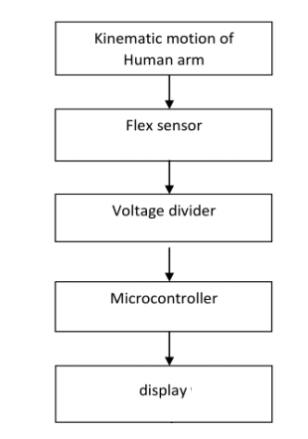

***Fig 2.1****Proposed methodology*

## 2.2 COMPONENTS USED IN THE PROJECT

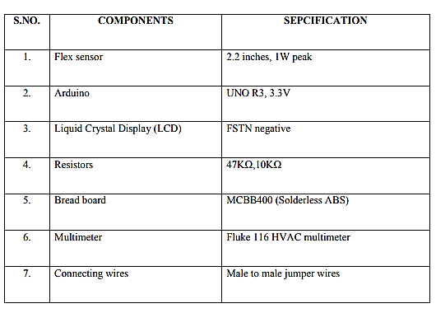

**2.3 ARDUINO**

A typical example of the Arduino board is Arduino Uno. It includes an ATmega328 microcontroller and it has 28-pins. The pin configuration of the Arduino Uno board is shown in the above. It consists of 14-digital I/O pins. Wherein 6 pins are used as pulse width modulation O/Ps and 6 analog I/Ps, a USB connection, a power jack, a 16MHz crystal oscillator, a reset button,  and an ICSP header. Arduino board can be powered either from the personal computer through a USB or external source like a battery or an adaptor. This board can operate with an external supply of 7-12V by giving voltage reference through the IORef pin or through the pin Vin.

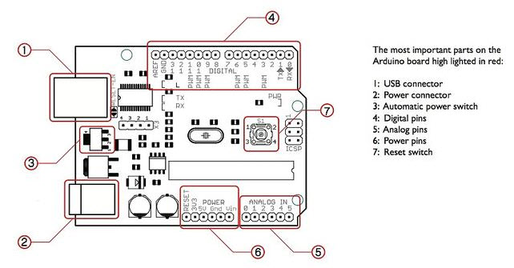

***Fig 2.2*** *Arduino Pin Diagram*

**DIGITAL INPUTS**

It comprises of 14-digital I/O pins, each pin take up and provides 40mA current. Some of the pins have special functions like pins 0 & 1, which acts as a transmitter and receiver respectively. For serial communication, pins-2 & 3 are external interrupts, 3,5,6,9,11 pins  delivers PWM o/p and pin-13 is used to connect LED.

**Analog inputs:** It has 6-analog I/O pins, each pin provide a 10 bits resolution.

**Aref:**  This pin gives a reference to the analog inputs.

**Reset:** When the pin is low, then it resets the microcontroller.

## 2.3.1.1 ARDUINO ARCHITECTURE

Basically, the processor of the Arduino board uses the Harvard architecture where the program code and program data have separate memory. It consists of two memories such as program memory and data memory. Wherein the data is stored in data memory and the code is stored in the flash program memory. The Atmega328 microcontroller has 32kb of flash memory, 2kb of SRAM 1kb of EPROM and operates with a 16MHz clock speed.

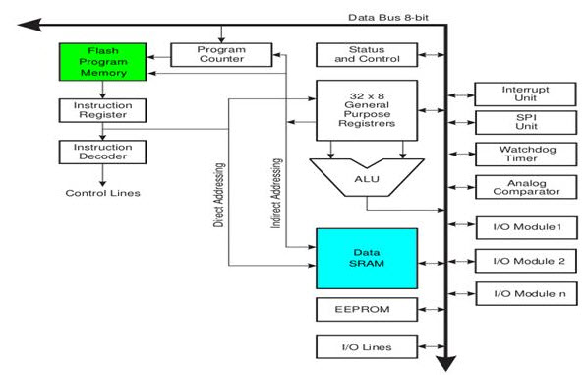

***Fig 2.3****. Arduino Architecture*

## 2.3.2 INTRODUCTION OF FLEX SENSOR

A **flex sensor** or **bend sensor** is a [sensor](https://en.wikipedia.org/wiki/Sensor) that measures the amount of [deflection](https://en.wikipedia.org/wiki/Deflection_(engineering)) or [bending](https://en.wikipedia.org/wiki/Bending). Usually, the sensor is stuck to the surface, and resistance of sensor element is varied by bending the surface. Since the resistance is directly proportional to the amount of bend it is used as [goniometer](https://en.wikipedia.org/wiki/Goniometer), and often called flexible [potentiometer](https://en.wikipedia.org/wiki/Potentiometer). The resistance of the sensor increases as the body bends. The one side of the body has a polymer ink coating which consists of conductive particles which move as the sensor is flexed and causes change in resistance. The sensor can be flexed in only one direction. The range of resistance is generally 25KΩ-65KΩ. The resistance of the sensor is 25KΩ when it is flat and when flexed to the maximum it is 65KΩ. The resistance at maximum should be at least twice the resistance at minimum. The resistance 25KΩ corresponds to an angle of zero degree and the resistance 65KΩ corresponds to 90°. The flex sensor is best suitable for a temperature range from -35°C to +85°C.

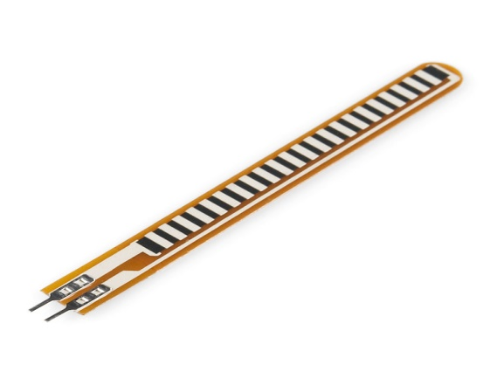

***Fig 2.4.*** *flex sensor*

**2.3.3 LCD**

A **liquid-crystal display** (**LCD**) is a [flat-panel display](https://en.wikipedia.org/wiki/Flat_panel_display) or other [electronically modulated optical device](https://en.wikipedia.org/wiki/Electro-optic_modulator) that uses the light-modulating properties of [liquid crystals](https://en.wikipedia.org/wiki/Liquid_crystal). Liquid crystals do not emit light directly, instead using a [backlight](https://en.wikipedia.org/wiki/Backlight)  or [reflector](https://en.wikipedia.org/wiki/Reflector_(photography)) to produce images in colour or [monochrome](https://en.wikipedia.org/wiki/Monochrome). LCDs are available to display arbitrary images (as in a general-purpose computer display) or fixed images with low information content, which can be displayed or hidden, such as preset words, digits, and [seven-segment displays](https://en.wikipedia.org/wiki/Seven-segment_display), as in a [digital clock](https://en.wikipedia.org/wiki/Digital_clock). They use the same basic technology, except that arbitrary images are made up of a large number of small [pixels](https://en.wikipedia.org/wiki/Pixel), while other displays have larger elements.

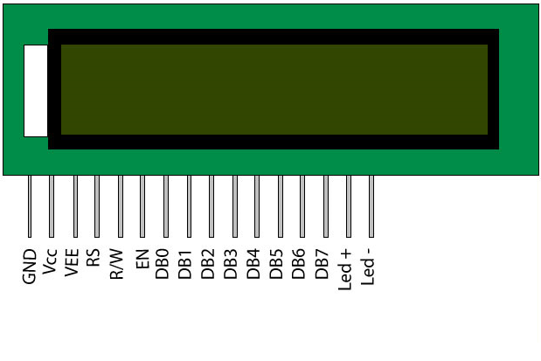

***Fig 2.5*** *LCD Display*

**2.3.4 POTENTIOMETER**

 Potentiometer is a three-[terminal](https://en.wikipedia.org/wiki/Terminal_(electronics)) [resistor](https://en.wikipedia.org/wiki/Resistor) with a sliding or rotating contact that forms an adjustable [voltage divider](https://en.wikipedia.org/wiki/Voltage_divider).[[1]](https://en.wikipedia.org/wiki/Potentiometer#cite_note-1) If only two terminals are used, one end and the wiper, it acts as a variable resistor or [rheostat](https://en.wikipedia.org/wiki/Potentiometer#Rheostat).

The measuring instrument called a [potentiometer](https://en.wikipedia.org/wiki/Potentiometer_(measuring_instrument)) is essentially a [voltage divider](https://en.wikipedia.org/wiki/Voltage_divider) used for measuring [electric potential](https://en.wikipedia.org/wiki/Electric_potential) (voltage); the component is an implementation of the same principle, hence its name.

Potentiometers are commonly used to control electrical devices such as volume controls on audio equipment. Potentiometers operated by a mechanism can be used as position [transducers](https://en.wikipedia.org/wiki/Transducer), for example, in a [joystick](https://en.wikipedia.org/wiki/Joystick). Potentiometers are rarely used to directly control significant power (more than a [watt](https://en.wikipedia.org/wiki/Watt)), since the power dissipated in the potentiometer would be comparable to the power in the controlled load

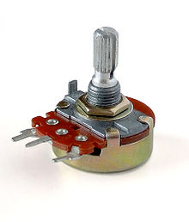

***Fig 2.6.****Potentiometer*

**2.4PROJECT EXPLANATION**

The resistance of the sensor increases as the body bends. The one side of the body has a polymer ink coating which consists of conductive particles which move as the sensor is flexed and causes change in resistance. The sensor can be flexed in only one direction.

The resistance at maximum should be at least twice the resistance at minimum. The resistance 25KΩ corresponds to an angle of zero degree and the resistance 65KΩ corresponds. The microcontroller ‘Arduino UNO R3’ is used to read the variable voltage from the voltage divider reads analog voltage is converted into a digital format by using the Analog to Digital Converter (ADC) inbuilt in the microcontroller. The digitalized voltage is converted to an equivalent degree of angle by using appropriate algorithms

The voltage divider consists of the flex sensor as the variable resistor and the other static resistor ranging from 10KΩ-100KΩ. Generally, the 47KΩ resistor is used to provide better result. The variable voltage decreases proportionately as the flex resistance increases. The measured angle can be displayed in LCD for easy visualization. The LCDs have a parallel interface which means that the microcontroller must manipulate several interface pins at once to control the display.

* 1. **.1 BLOCK DIAGRAM**

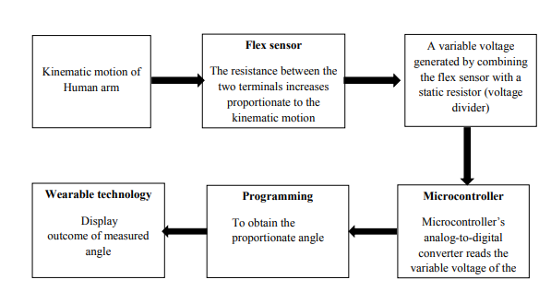

***Fig 2.7*** *Block Diagram*

**2.4.2 CIRCUIT DIAGRAM**

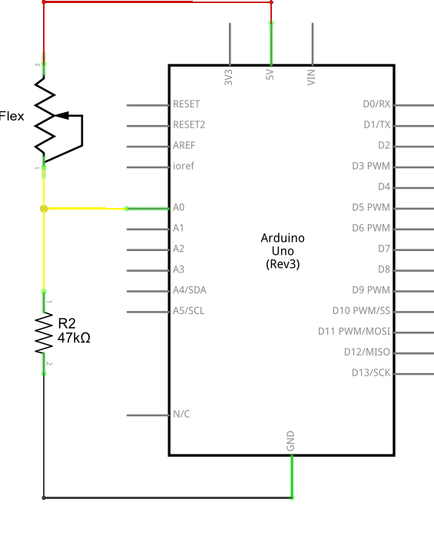

***Fig 2.8*** *Circuit Diagram*

## CHAPTER 3

## PROGRAMMING FUNCTIONS AND APPLICATIONS

### 3.1 PROGRAMMING ARDUINO

The main advantage of the Arduino technology is, you can directly load the programs into the device without the need of a hardware programmer to burn the program. This is done because of the presence of the 0.5KB of boot loader that allows the program to be dumped into the circuit. The Arduino tool window contains a toolbar with a various buttons like new, open, verify, upload and serial monitor. And additionally it comprises of a text editor (employed to write the code), a message space (displays the feedback) like showing the errors, the text console, that displays the o/p & a series of menus just like the file, tool menu & edit.

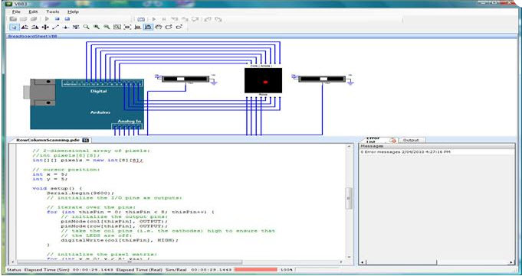

**Fig 3.1 Arduino Program**

* [Programming into the](http://www.edgefxkits.com/blog/labview-programming-language-uses/) Arduino board is called as sketches. Each sketch contains of three parts such as Variables Declaration, Initialization and Control code. Where, Initialization is written in the setup function and Control code is written in the loop function.
* The sketch is saved with .ino and any operation like opening a sketch, verifying and saving can be done using the tool menu.
* The sketch must be stored in the sketchbook directory.
* Select the suitable board from the serial port numbers and tools menu.
* Select the tools menu and click on the upload button, then the boot loader [uploads the code on the microcontroller](http://www.edgefxkits.com/blog/free-ebook-to-learn-and-design-your-own-microcontroller-projects/).

**3.1.1 PROGRAM CODING:**

#include <LiquidCrystal.h>

const int FLEXPIN = A0;

const float VCC = 4.98;

const float RDIV = 10000.0;

const int rs = 12, en = 11, d4 = 5, d5 = 4, d6 = 3, d7 = 2;

LiquidCrystal lcd(rs, en, d4, d5, d6, d7);

const float STRAIGHTRESISTANCE=59591.0;

const float BENDRESISTANCE = 177444.0;

void setup()

{

Serial.begin(9600);

pinMode(FLEXPIN, INPUT);

lcd.begin(16, 2);

lcd.print("DIGI GONIO");

}

void loop()

{

int flexADC = analogRead(FLEXPIN);

float flexV = flexADC * VCC / 1023.0;

float flexR = RDIV * (VCC / flexV - 1.0);

Serial.println("Resistance: " + String(flexR) + " ohms");

float angle = map(flexR, STRAIGHTRESISTANCE, BENDRESISTANCE,

0, 90.0);

Serial.println("Bend: " + String(angle) + " degrees");

lcd.setCursor(1,1);

lcd.print("angle: " + String(angle) + " deg");

Serial.println();

delay(10000);

}

### 3.1.2 BASIC FUNCTIONS OF ARDUINO TECHNOLOGY

* Digital read pin reads the digital value of the given pin.
* Digital write pin is used to write the digital value of the given pin.
* Pin mode pin is used to set the pin to I/O mode.
* Analog read pin reads and returns the value.
* Analog write pin writes the value of the pin.
* Serial. Begins pin sets the beginning of serial communication by setting the rate of bit.

### 3.1.3 ADVANTAGES OF ARDUINO TECHNOLOGY

* It comes with an open supply hardware feature that permits users to develop their own kit
* The software of the Arduino is well-suited with all kinds of in operation systems like Linux, Windows, and Macintosh, etc.
* It also comes with open supply software system feature that permits tough software system developers to use the Arduino code to merge with the prevailing programming language libraries and may be extended and changed.
* For beginners, it is very simple to use.

#### 3.1.4 APPLICATIONS OF ARDUINO TECHNOLOGY

#### The Obstacle Avoidance Robot Operated with Arduino

The main concept of this project is to design a robot using ultrasonic sensors to avoid the obstacle. A robot is a machine and it is a combination of programs instructions and motors. It can perform some task with some guidance or automatically. This robotic vehicle has an intelligence which is built  inside of the robot. When a obstacle problem comes ahead of it then, it guides itself. This robot is designed with a microcontroller from Atmel family of Arduino board.

[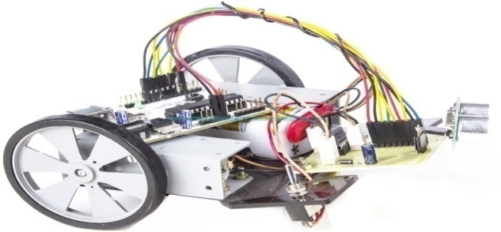](http://www.edgefxkits.com/blog/wp-content/uploads/Arduino-Operated-Obstacle-Avoidance-Robot-Project-Kit-by-Edgefxkits.com_.jpg)

***Fig 3.2 arduino application(1)***

#### Arduino based Controlling of Electrical Appliances using IR

#### The main goal of this project is to control the electrical appliances using an IR remote. This project uses the TV remote to transmit the coded data, then it is received by a sensor which is interfaced to the control unit. The proposed system controls the electrical loads depending on the transmitted data from the remote. Operating electrical appliances are very difficult for handicapped or senior people. This project gives the solution by integrating household appliances to a control unit which can be operated with a TV remote.

[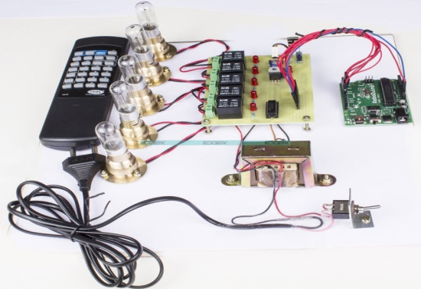](http://www.edgefxkits.com/blog/wp-content/uploads/Arduino-based-Electrical-Appliances-Control-using-IR-Project-Kit-by-Edgefxkits.com_.jpg)

***Fig 3.2***  *Arduino application(2)*

**3.2 APPLICATIONS OF FLEX SENSOR**

**Dent damage detection**

Dent or damage detection earlier was done in German research project KESS by using sound emission analysis. Sound emission analysis was earlier used for aircrafts. In project KESS, a test car has been equipped with eleven structure-borne sound sensors. Every sensor is mounted to a single vehicle body part. The digital signal is then forwarded to internal microcontroller to be analyzed, and a notification message is sent to electronic controller unit if and only if a minor damage occurs. The vibrations of vehicle in various test drives have been recorded on different road surfaces like blacktop, cobblestone, dirt road, field road and concrete highway. But such a system may not give accurate results in case of a vehicle crash, since natural frequency of metal panels change vigorously after large deformations, and damage detection may be inappropriate. Hence a damage detection system should be able to record the shape of the metal sheets at all times to detect a dent or damage. A shape tape has been created by. Bend and twist are measured at 6 cm intervals by two fiber optic flex sensors. By summing the bends and twists of the 16 sensors along shape tape, the shape of the tape relative to first sensor can was recorded. A flex sensor can be Thus it is used to find out the dents correctly

**CHAPTER 4**

**RESULT AND CONCLUSION**

**4.1 PICTURE OF THE PROJECT**

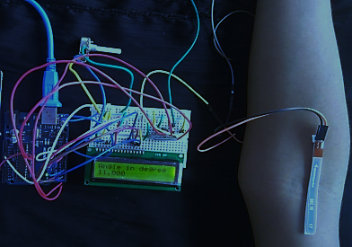

***Fig 4.1*** *snapshot of project*

**4.2.TESTING IMAGES**

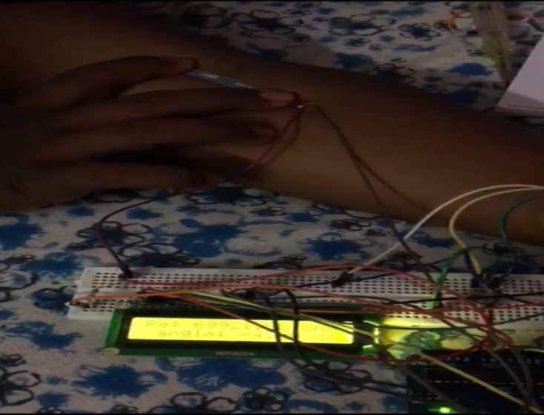

***Fig 4.1.2*** *testing images*

**4.2 FUTURE SCOPE**

This type of digital goniometer could make a great impact in the growing digital world the further improvement is implementation of IOT so that the patients could be easily guided by the world class doctors by checking their goniometer data which could available at the cloud server. So it could be more useful for the patients. Even though a vibrating device could also be associated with goniometer so that the physiotherapist can send their massaging signals through wireless communication hence the digital goniometer could be further developed in such a way the patients achieve complete reliance and satisfaction.

**4.3 CONCLUSION**

The range of motion of the patient arm with muscle stiffness is measured by using the flex sensor and displayed in the LCD display. This digitalization provokes the self- rehabilitation of the patient with post- operative total joint replacement surgery. In future, this prototype can be developed into a wearable goniometer device of affordable price. It is planned to design by making a band like cloth and placing the sensor in a brace that can be worn by the patients were the replacement has done.